# ASSIGNMENT - 1

|  |  |
| --- | --- |
| Date | 3 October 2022 |
| Team ID | PNT2022TMID54076 |
| Project Name | Personal Assistance for Seniors Who Are Self-Reliant. |
| Maximum Marks | 2 Marks |

**Objective:**

Create an Arduino project for a smart home with two sensors.

# Sensors Used:

* Ultrasonic Sensor
* PIR Sensor

# Circuit Diagram:

**Link:** https://www.tinkercad.com/things/hpRZxe6JBbG-bodacious-snicket

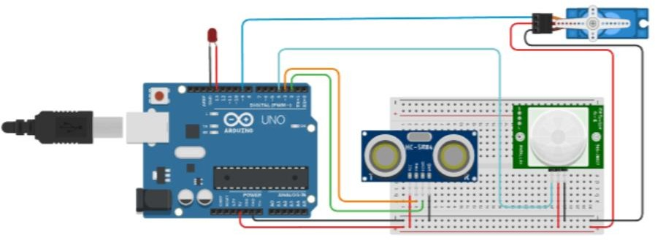

# Code:

#include <Servo.h> Servo myservo; #define echoPin 2

#define trigPin 3 int led = 13;

int sensor = 4; int state = LOW; int val = 0;

long duration; int distance;

void setup() { myservo.attach(9); pinMode(led, OUTPUT); pinMode(sensor, INPUT); pinMode(trigPin, OUTPUT); pinMode(echoPin, INPUT); Serial.begin(9600);

}

void loop() { digitalWrite(trigPin, LOW); delayMicroseconds(2); digitalWrite(trigPin, HIGH); delayMicroseconds(10); digitalWrite(trigPin, LOW);

duration = pulseIn(echoPin, HIGH); distance = duration * 0.034 / 2; Serial.print("Distance: "); Serial.print(distance); Serial.println(" cm");

val = digitalRead(sensor); if (val == HIGH) {

digitalWrite(led, HIGH); delay(500);

if (state == LOW) { Serial.println("Motion detected!"); state = HIGH;

}

}

else {

digitalWrite(led, LOW);

delay(500);

if (state == HIGH){ Serial.println("Motion stopped!"); state = LOW;

}

}

if(distance<=40){

int val = map(180, 0, 1023, 0, 180); myservo.write(val); Serial.println("Door Open"); delay(2000);

val = map(-180, 0, 1023, 0, 180);

myservo.write(val); Serial.println("Door Close");

}

}

# OUTPUT:

